**FULL STACK PROJECT**

**(2018-19)**

TRAVELLING WEBSITE

**Final Report**



**Institute of Engineering & Technology**

**Team Members**

Shruti Sharma

(University Roll No-171500332)

Sahil Srivastava

(University Roll No-171500281)

## Supervised By

**Mr. Pankaj Kapoor Sir**

**Asst. Professor**

**Department of Computer Engineering & Applications**



**Department of computer Engineering and Applications**

**GLA University, Mathura**

**17 km. Stone NH#2, Mathura-Delhi Road, P.O. – Chaumuhan,**

**Mathura – 281406**

**Declaration**

I hereby declare that the work which is being presented in the Full Stack Project  **“Travelling Website ”,** in partial fulfillment of the requirements for Mini project viva voce, is an authentic record of my own work carried under the supervision of “ **Mr. Pankaj Kapoor Sir ” ,** Asst. Professor**,** Departmentof Computer Engineering & Applications

**Team Members**

Sahil Srivastava (University Roll No-171500281)

Shruti Sharma (University Roll No-171500332)

Course: B.Tech(CSE)

Year: 3rd

Semester: V

**SYNOPSIS**

**Introduction to the Project**:

Travelling Website is a static website. The main purpose of “ Travelling Website ” is to provide a convenient way for a customer to book packages for holidays to different places in India and outside India.. In this project, we have made an easier task of searching places and for booking vehicles. In the present system a customer has to approach various agencies to find details of places and to book tickets. This often requires a lot of time and effort. We provide approach skills to critically examine how a tourist visits and its ability to operate in an appropriate way when dealing with the consequences of tourism, locally, regionally, and nationally including visitor security and ecological influences. It is tedious for a customer to plan a particular journey and have it executed properly. Our website offers real time data access, minimizes maintenance cost ,24*7 interactions with customers, saves time and money, minimizes order processing costs, instant reservation or booking facilities of flights, tour packages etc.

**Main Features of this will be**

* Efficient & fast online booking engines.
* Worldwide car rentals.
* Last minute package tours.
* Clear pricing without hidden fees.
* Huge beautiful images.
* Support page which consists of frequently asked questions, reservation policy, lowest rate challenge etc.

**Technology Used:**

Basically we are working on Full Stack Technology which will provide a complete UI for the user.

We have used:

- HTML5

- CSS3

- JavaScript

**Audience Target:**

Zero investment in training of the users of this application since the entire application is browser based, decrease order processing costs, economic cost of interacting with customers, simple way to perform cancellation of the earlier reservations made, swift and easy reservation/booking of hotels/flights/tour packages/car rental for customers, usual place to have entire reservation activities and entire reservations can be done with single login, real-time data access and maintenance.

**Future Scope:**

Any tourist agency can use make use of it for saving customer details in database. Tourism group can make use it for managing location, location, vehicles details. We will include more functionality as per the user requirements, make this website responsive, we will improve our home page, as it is the main page which attracts the customers. Later on php and mysql can be used to make the webpage user friendly.

**ACKNOWLEDGEMENT**

It is my pleasure to acknowledge the assistance of a number of people without whose help this project would not have been possible.

First and foremost, I would like to express our gratitude to **Mr. Pankaj Kapoor Sir,** my project guide, for providing invaluable Encouragement, guidance and assistance. I would like to thank the institute staff for the operation extended to us throughout the project. After doing this project I can confidently say that this experience has not only enriched me with technical knowledge but also has unparsed the maturity of thought and vision. The attributes required being a successful professional.

**Abstract**

The recent past showed a greater interest in recommender techniques. Now-a-days there are many travel packages existing from different websites to almost all the places over the world. A customer finds it very difficult to search for the best package as he/she has to browse multiple websites, contact many travel agents and etc. which is a tedious process and is time consuming. There should be a system where the user should find the best package on the Internet with a single click. To address this issue, we adopt Travel Package Recommendation System which offers the best package among all the other packages that are on the web. This project will help tourist to suggest the best Travel Package among all the package deals on the web. On multiple demands of tourist that is, a customer will select a travel package for a particular place based on the recommendations provided by the previous customers who had experience with the package. Therefore, according to the personalized recommendations, he/she will choose the best package that is on the web. The website will help the users as it is cost-effective, and provides 24x7 availability.

**Table of Content**

**Declaration……………………………………………………………** 2

**Synopsis………………………………………………………………** 3

**Acknowledgement…………………………………………………….5**

**Abstract………………………………………………………………..**6

**Feasibility study……….………………………………………………**9

1. **Introduction**  
   1. Purpose…………………………………………………………………12
   2. Scope..………………………………………………………………….12
   3. Objective…………………………………………………………….....12
   4. Features …...…………………………………………………………..13
2. **Software Requirement Specification**

2.1 Software Requirement Analysis………………………………………..14

2.2 Problem Definition…..…………………………………………………18

1. **Software Design**
   1. Data Flow ………………………………………………………….........19

3.2.1 Context level DFD ……………………………….……….…………..20

3.3 Use Case………………………………………………………………...21

1. **Testing**…..…………………………………………….………………......22
2. **Implementation and Interface**…………….……………………24

**6. Bibliography**…………...…………………..………………………40

**FEASIBILITY STUDY**

Preliminary investigation examines project feasibility , the likelihood the system will be useful to the organization. The main objective of the feasibility study is to test the Technical, Operational and Economical feasibility for adding new modules and debugging old running system. All systems are feasible if they are given unlimited resources and infinite time. There are aspects in the feasibility study portion of the preliminary investigation:

Technical Feasibility  
Operation Feasibility  
Economical Feasibility

* **ECONOMIC FEASIBILITY**

Economic analysis is most frequently used for evaluation of the effectiveness of the system. More commonly known as cost/benefit analysis the procedure is to determine the benefits and savings that are expected from a system and compare them with costs, decisions is made to design and implement the system. This part of feasibility study gives the top management the economic justification for the new system. This is an important input to the management, because very often the top management does not like to get confounded by the various technicalities that bound to be associated with a project of this kind. A simple economic analysis that gives the actual comparison of costs and benefits is much more meaningful in such cases. In the system, the organization is most satisfied by economic feasibility. Because, if the organization implements this system, it need not require any additional hardware resources as well as it will be saving lot of time.

* **TECHNICAL FEASIBILITY**

The technical issue usually raised during the feasibility stage of the investigation includes the following:

Does the necessary technology exist to do what is suggested?  
Do the proposed equipments have the technical capacity to hold the data required to use the new system? Will the proposed system provide adequate response to inquiries, regardless of the number or location of users? Can the system be upgraded if developed? Are there technical guarantees of accuracy, reliability, ease of access and data security?

* **BEHAVIOURAL FEASIBILITY**

People are inherently resistant to change and computer has been known to facilitate changes. An estimate should be made of how strong the user is likely to move towards the development of computerized system. These are various levels of users in order to ensure proper authentication , authorization and security of sensitive data of the organization.

**Introduction**

Travelling Website website is a static website. The main purpose of “ Travelling Website ” website is to provide a convenient way for a customer to book packages for holidays to different places in India and outside India.. In this project, we have made an easier task of searching places and for booking vehicles. In the present system a customer has to approach various agencies to find details of places and to book tickets. This often requires a lot of time and effort. We provide approach skills to critically examine how a tourist visits and its ability to operate in an appropriate way when dealing with the consequences of tourism, locally, regionally, and nationally including visitor security and ecological influences. It is tedious for a customer to plan a particular journey and have it executed properly. Our website offers real time data access, minimizes maintenance cost ,24*7 interactions with customers, saves time and money, minimizes order processing costs, instant reservation or booking facilities of flights, tour packages etc.

Therefore, a user-friendly, beautiful, interactive and intuitive website is must to attract more customers and generate more leads. With a website, your business will lead you to another level of achievements. So, if still don’t own a website for your travel business then you are definitely missing out on so many things and so much behind your competitors. Or you can simply contact us to make one for you.

Moving on, let's talk some important factors and beneficiaries our travel business will get with the help of a website.

## Attracts an eye of new clients

## Easy to find and book tours

## Help to create brand image and value

## 24/7 interaction mode.

## Easy distribution of new offers

**1.1 Purpose**

The objective of the project is to make a Travelling Website website (only the front-end) to help the customers to get the best holiday package at an effective cost within a limited time frame. Our website helps a great deal in planning your trip, where you can book your flights, hotels, cruises, vacation packages, customize your vacation and even get honest traveler reviews about the place. Here you can easily get all the information related to travel and easily asked travel-related queries.

**1.2 Scope**

Online travel booking systems has truly transformed the way people plan their tours along with how travel agencies all over the world offer their services to the individual. In earlier times, local tour operators and travel agencies were totally dependent on the travel needs and requirements of the people who are present nearby. Their services were limited to a particular geographical area, which also restricts their profits and revenue. Furthermore, offering the customers with full-fledged travel services during the tour were quite difficult as well.

**1.3 Objective**

1. Provide a high standard of services suitable for individuals seeking relaxing, comfortable and memorable experiences in the hospitality and tourism industry.
2. Provide the tourist market with the quality personal required by the tourism industry.
3. Produce expeditions and memories that would satisfy each and every single of the customers.
4. Evaluate current cultural, economic, and social issues affecting the tourism and travel industry.
5. Participate in both local and regional community service by providing general lectures, consultation, and training programs.

* 1. **Features**
* Predictive search
* Huge beautiful images
* Customer reviews
* Clear pricing without hidden fees
* Use evocative and interesting copy
* Simple checkout
* Minimizes maintenance cost
* 24*7 interactions with customers
* Saves time and money
* Minimizes order processing costs
* Instant reservation or booking facilities of flights
* Tour packages

**­**

**Software Requirement Specification**

**2.1 Software Requirement Analysis**

The technologies and tools used by me to develop this project are:

Basically we are working on Full Stack Technology which will provide a complete UI for the user.

Software Used:

-Web Browser

- HTML

- CSS3

- Any Editor(Brackets)

- JavaScript

Let us take an overview on all the tools used in our project-

**HTML**

HTML stands for Hyper Text Markup Language.

HTML is used to create web pages and web applications.

HTML is widely used language on the web.

We can create a static website by HTML only.

Technically, HTML is a Markup language rather than a programming language.

**Hyper Text:** Hyper Text simply means "Text within Text." A text has a link within it, is a hypertext. Whenever you click on a link which brings you to a new webpage, you have clicked on a hypertext. HyperText is a way to link two or more web pages (HTML documents) with each other.

**Markup language:** A markup language is a computer language that is used to apply layout and formatting conventions to a text document. Markup language makes text more interactive and dynamic. It can turn text into images, tables, links, etc.

**Web Page:** A web page is a document which is commonly written in HTML and translated by a web browser. A web page can be identified by entering an URL. A Web page can be of the static or dynamic type. **With the help of HTML only, we can create static web pages**.

Hence, HTML is a markup language which is used for creating attractive web pages with the help of styling, and which looks in a nice format on a web browser. An HTML document is made of many HTML tags and each HTML tag contains different content.

**CSS3**

CSS stands for Cascading Style Sheet.

CSS is used to design HTML tags.

CSS is a widely used language on the web.

HTML, CSS and JavaScript are used for web designing. It helps the web designers to apply style on HTML tags.

CSS stands for Cascading Style Sheets. It is a style sheet language which is used to describe the look and formatting of a document written in markup language. It provides an additional feature to HTML. It is generally used with HTML to change the style of web pages and user interfaces. It can also be used with any kind of XML documents including plain XML, SVG and XUL.

CSS is used along with HTML and JavaScript in most websites to create user interfaces for web applications and user interfaces for many mobile applications.

You can add new looks to your old HTML documents.

You can completely change the look of your website with only a few changes in CSS code.

## 1) Solves a big problem

Before CSS, tags like font, color, background style, element alignments, border and size had to be repeated on every web page. This was a very long process. For example: If you are developing a large website where fonts and color information are added on every single page, it will be become a long and expensive process. CSS was created to solve this problem. It was a W3C recommendation.

## 2) Saves a lot of time

CSS style definitions are saved in external CSS files so it is possible to change the entire website by changing just one file.

## 3) Provide more attributes

CSS provides more detailed attributes than plain HTML to define the look and feel of the website.

**JavaScript**

JavaScript is an object-based scripting language which is lightweight and cross-platform.

JavaScript is not a compiled language, but it is a translated language. The JavaScript Translator (embedded in the browser) is responsible for translating the JavaScript code for the web browser.

JavaScript is used to create interactive websites. It is mainly used for:

Client-side validation,

Dynamic drop-down menus,

Displaying date and time,

Displaying pop-up windows and dialog boxes (like an alert dialog box, confirm dialog box and prompt dialog box),

Displaying clocks etc.

It provides code re usability because single JavaScript file can be used in several html pages.

An external JavaScript file must be saved by .js extension. It is recommended to embed all JavaScript files into a single file. It increases the speed of the webpage.

**2.2 Problem Definition**

The purpose of website is established fact that internet users are increasing today. One of the main purpose of the website is to facilitate the offline customers online because they cannot spend their precious time in market trying to find out the best deals.

India is a country where in a few day holiday, you can enjoy a lot. The problem is that although having many websites but they offer different kind of services. The customers are enjoying a lot but there is a lack of relationship between websites and customers and hence we are establishing that relationship by caring and serving all customers in the same manner that we wish to be served. Our priority will be our customers and their requirements. We require a strong and reliable frontend which can withhold the customers on out site. We will provide right choice to the people and beware them from the false advertising. We will answer them with their queries and advise them best which is cost-effective.

**Software Design**

This is the designing portion of the project which defines software solutions to one or more sets of problem. One of the main component of software design is the software requirement analysis.

**3.1 Data Flow Diagram**

The **database schema** of a database system is its structure described in a formal language supported by the database management system (DBMS). The term "[schema](https://en.wiktionary.org/wiki/schema)" refers to the organization of data as a blueprint of how the database is constructed (divided into database tables in the case of relational databases). The formal definition of a database schema is a set of formulas (sentences) called integrity constraints imposed on a database. These integrity constraints ensure compatibility between parts of the schema.

**3.1.(a) Zero Level DFD**

A context level DFD is the most basic form of DFD. It aims to show how the entire system works at a glance. There is only one process in the system and all the data flows either into or out of this process. Context level DFD’s demonstrates the interactions between the process and external entities.

TOURS IN INDIA

ABOUT US

INTERNATIONAL TOURS

SUPPORT

DESTINATIONS

TRANSPORT

**Fig.3.1.(a) Zero Level DFD**

**3.2 UML Diagrams**

The UML is a standard visual modelling language intended to be used for modelling business and similar processes.

**3.2.(a) Use Case**

A **use case** is a list of actions or event steps typically defining the interactions between a role (known in the [Unified Modeling Language](https://en.wikipedia.org/wiki/Unified_Modeling_Language) as an [actor](https://en.wikipedia.org/wiki/Actor_(UML))) and a system to achieve a goal. The actor can be a human or other external system. [Use case analysis](https://en.wikipedia.org/wiki/Use-case_analysis) is an important and valuable [requirement analysis](https://en.wikipedia.org/wiki/Requirement_analysis) technique that has been widely used in modern software engineering.

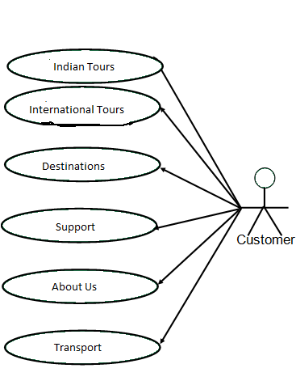

**Fig.3.2.(a) Use case Diagram**

**TESTING**

**5.1 Introduction**

Software testing is a critical element of software quality assurance and represents the ultimate review of specification, design and coding. In fact, testing is the one step in the software engineering process that could be viewed as destructive rather than constructive.

A strategy for software testing integrates software test case design methods into a well- planned series of steps that result in the successful construction of software. Testing is the set of activities that can be planned in advance and conducted systematically. The underlying motivation of program testing is to affirm software quality with methods that can be economically and effectively apply to both strategies to both large and small scale system.

The following are the Testing Objectives:

* Testing is a process of executing a program with the intent of finding an error.
* A good test has a high probability of finding an as yet undiscovered error.
* A successful test is one that uncovers an as yet undiscovered error.

**5.2 Design of Test cases & scenarios**

The objective is to design tests that systematically uncover different classes of errors and do so with a minimum amount of time and effort. Testing cannot show the absence of defects. It can only show that software defects are present.

**5.2.1 Integration Testing**

Modules integrated by moving down the program design hierarchy. Can use depth first or breadth first top down integration verifies major control and

decision points early in design process. Top- level structure tested most. Depth first implementation allows a complete function to be implemented, tested and demonstrated and does depth first implementation of critical function early. Top down integration forced (to some extent) by some development tools in program with graphical user interfaces.

Begin construction and testing with atomic modules (lowest level modules). Bottom up integration testing as its name implies begins construction and testing with atomic modules. Because molecules are integrated from the bottom up, processing required for modules subordinates to a given level is always available and need for stubs is eliminated.

**5.2.2 Validation Testing**

Validation testing aims to demonstrate that the software functions in a manner that can be reasonably expected by the customer. This tests conformance the software to the Software Requirements Specification

**5.2.2.1 Validation Test Criteria**

A set of black box test is to demonstrate conformance with requirements. To check that all functional requirements satisfied, all performance requirements achieved, documentation is correct and ‘human engineered’, and other requirements are met e.g. Compatibility ,Error recovery and Maintainability

When validation tests fail it may be too late to correct the prior to scheduled delivery. Need to negotiate method of resolving deficiencies with the customer.

**User Implementations and Interface**

* 1. **HOME PAGE**

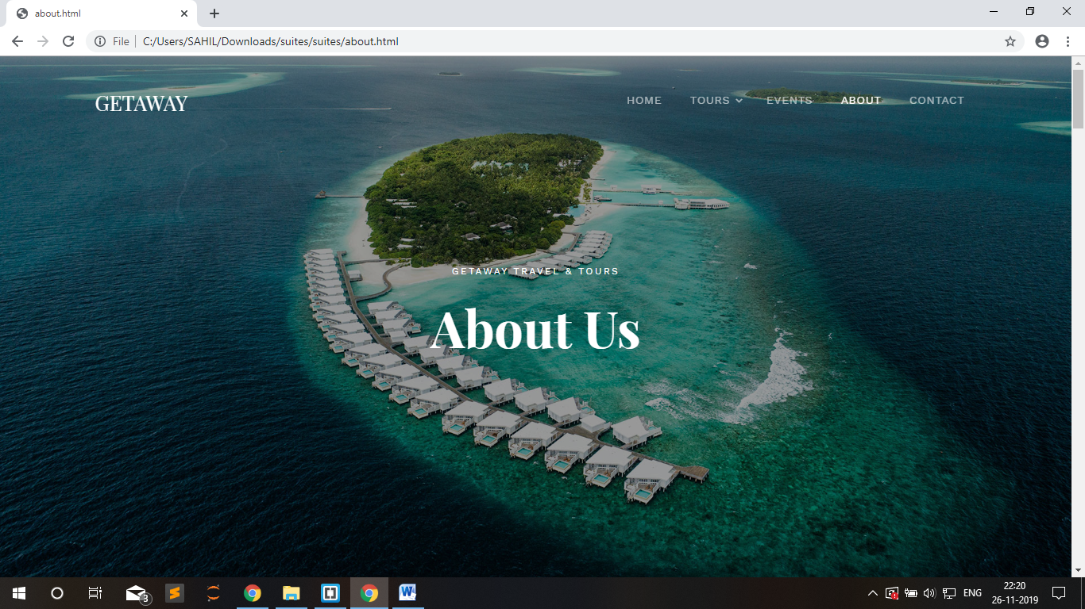

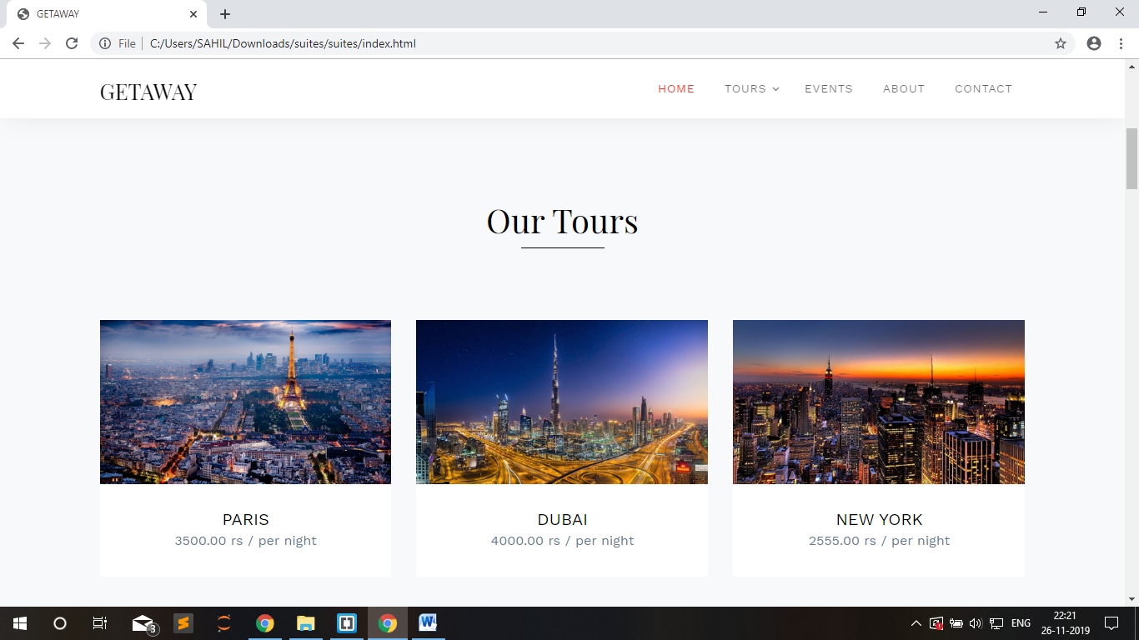

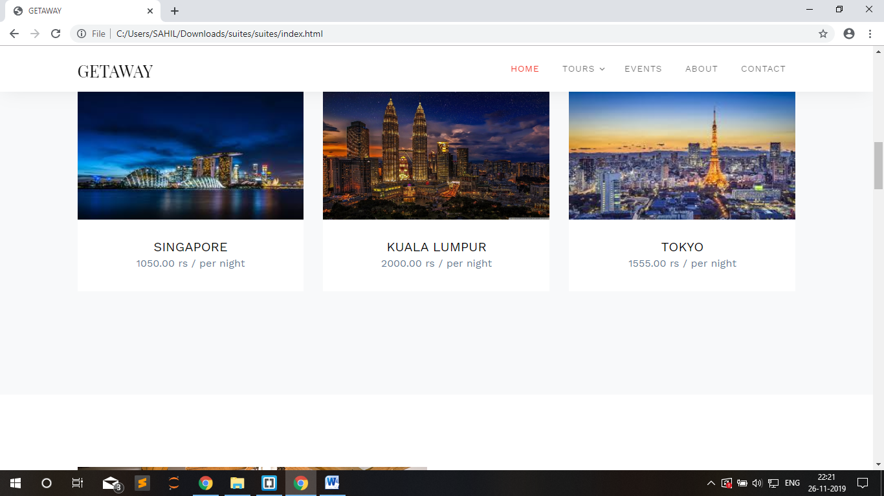

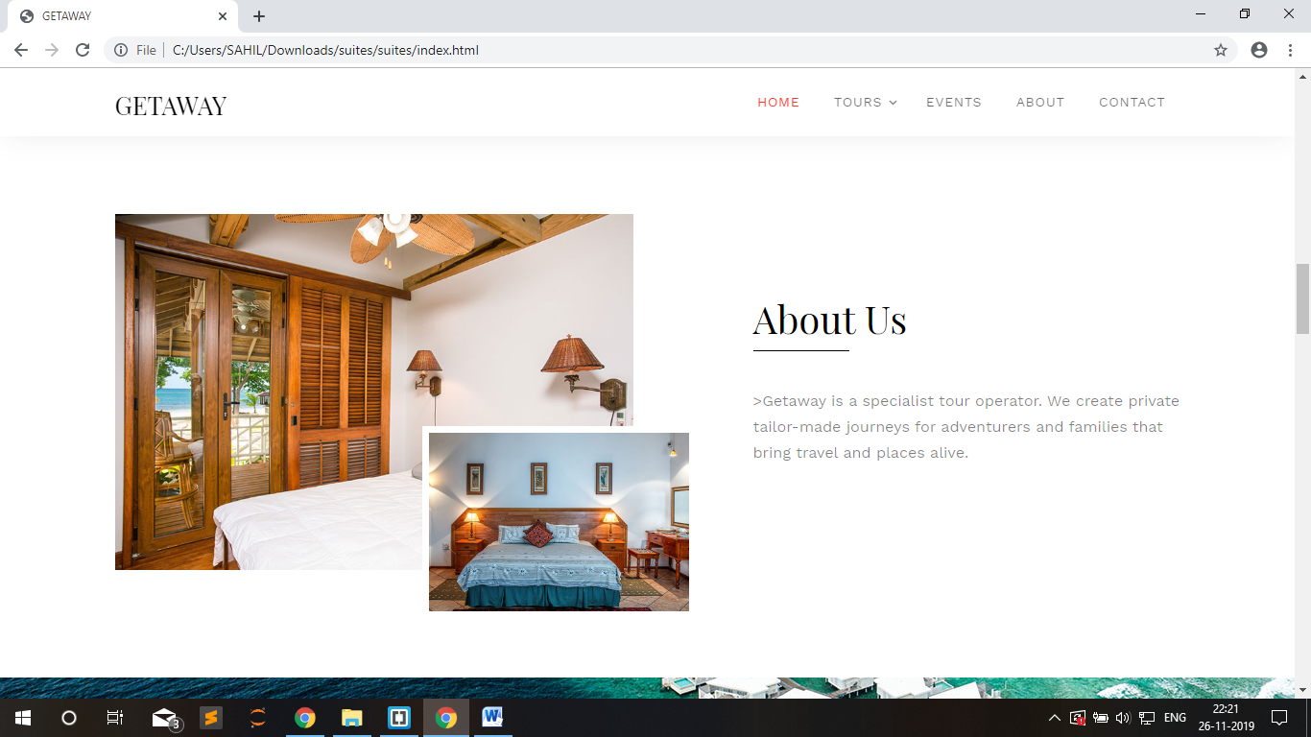

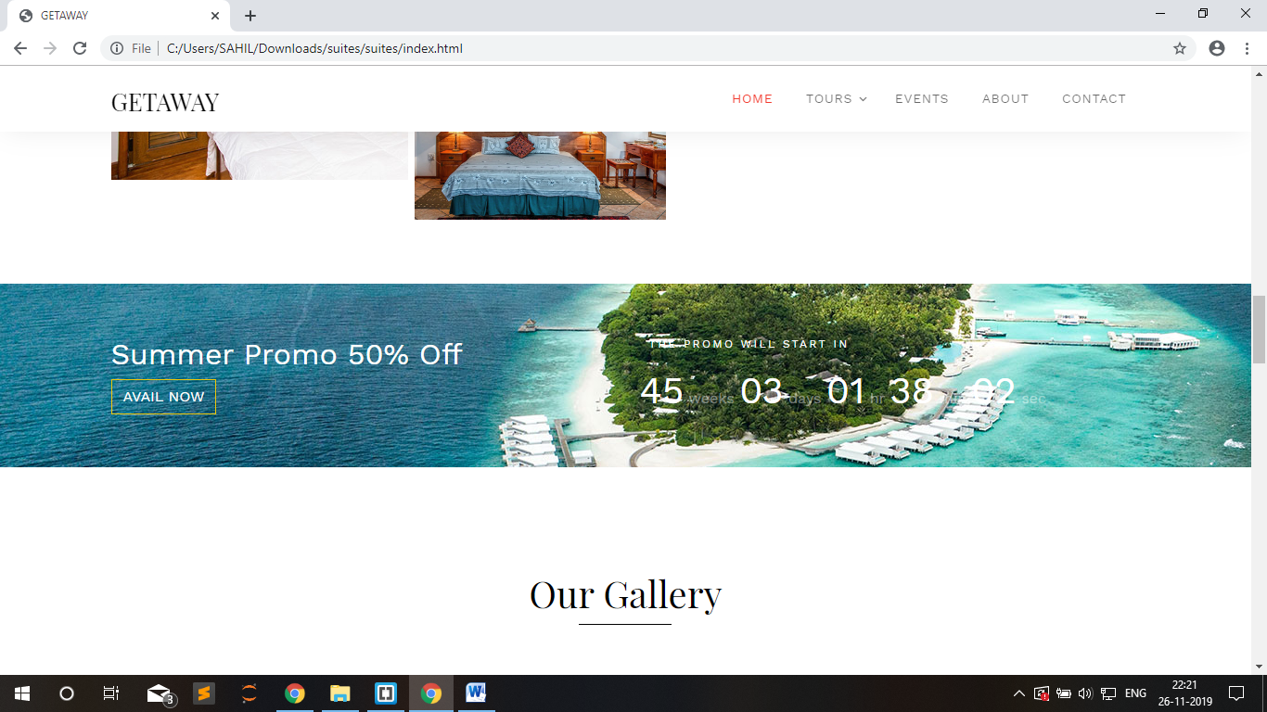

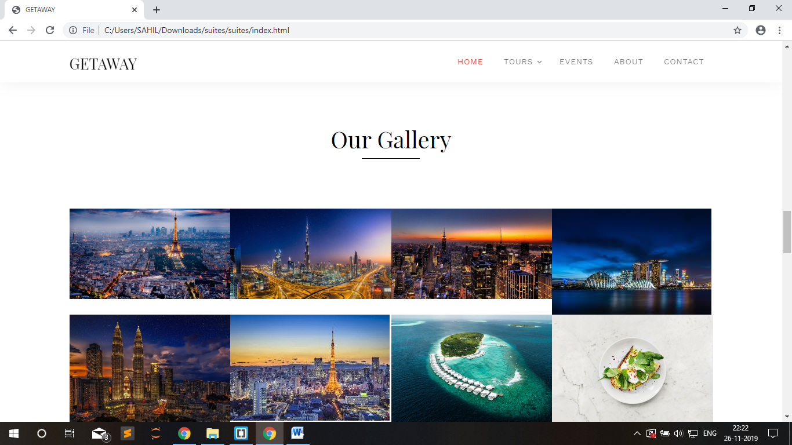

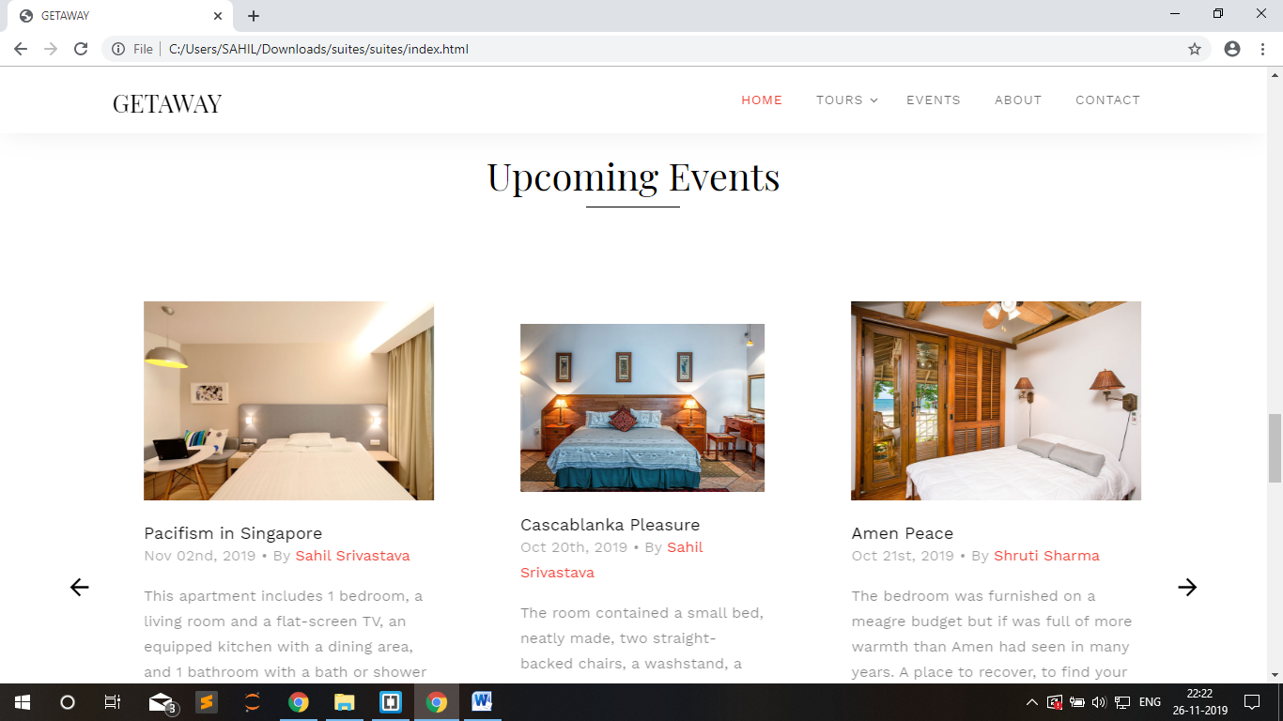

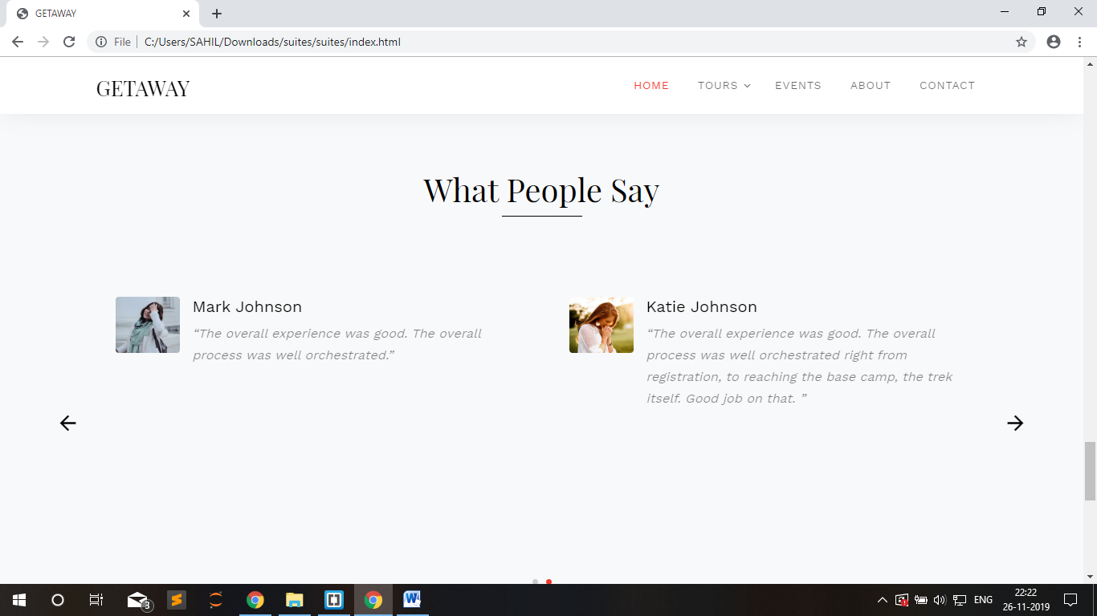

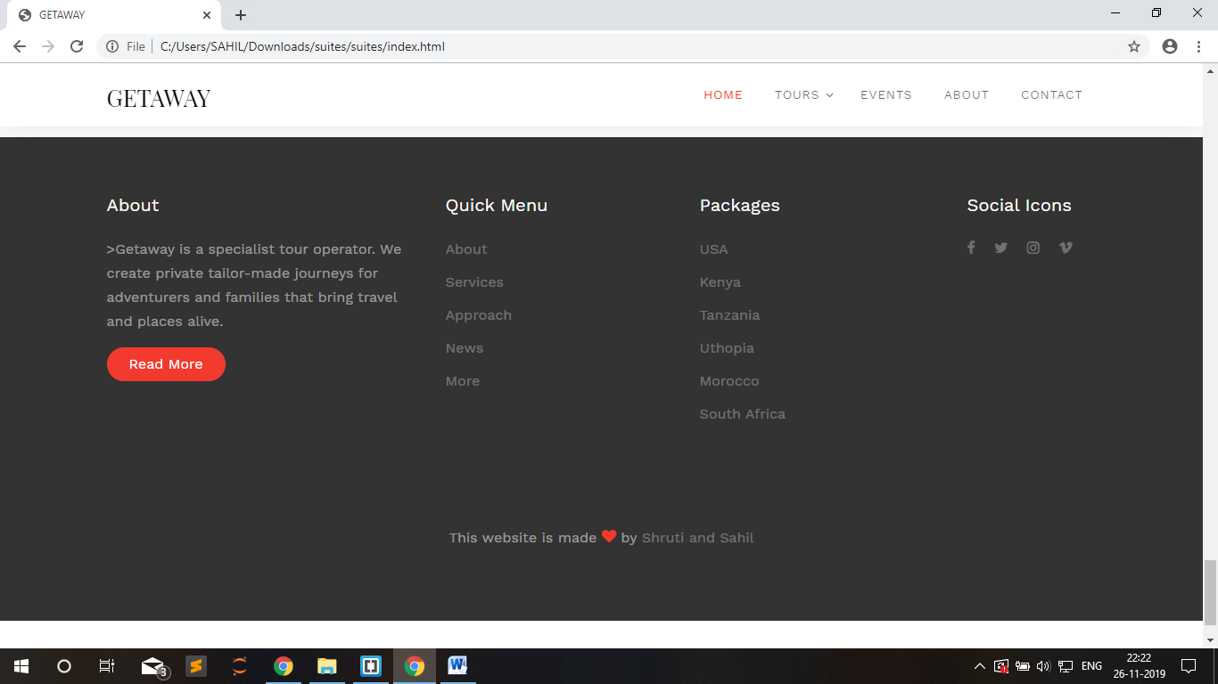

* 1. **TOURS page**

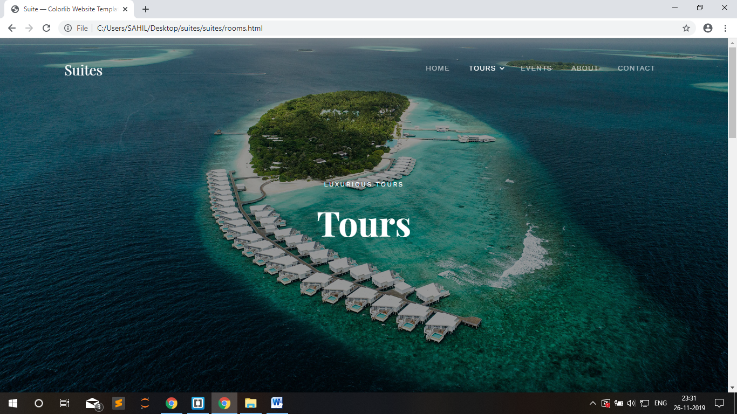

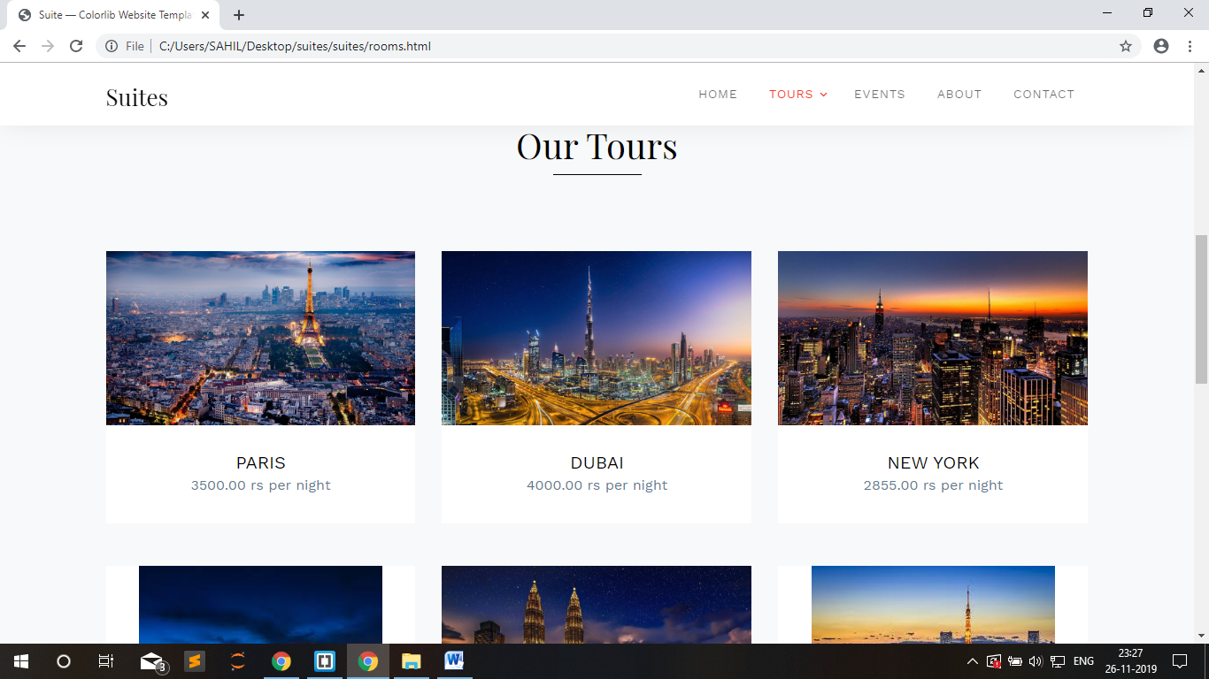

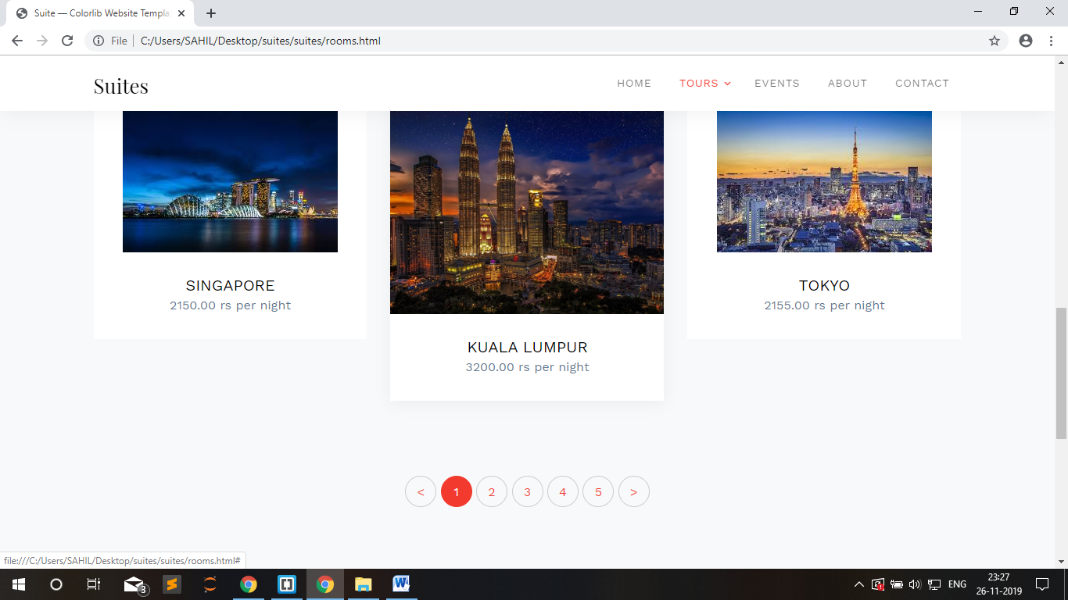

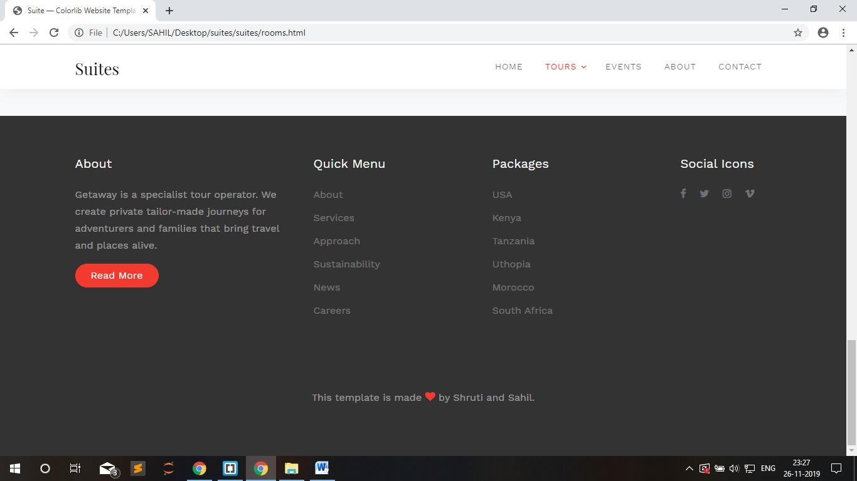

* 1. **ABOUT PAGE**

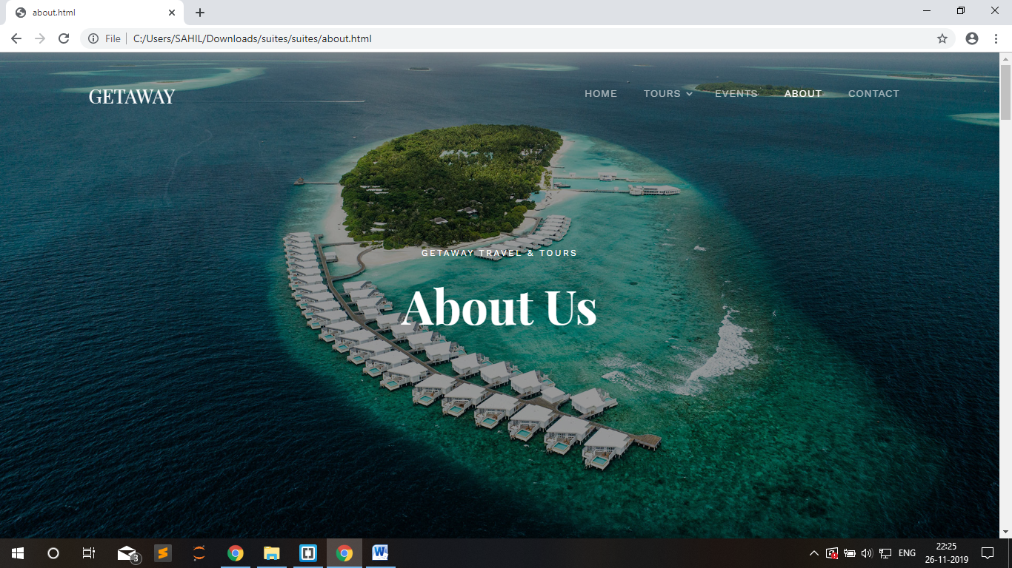

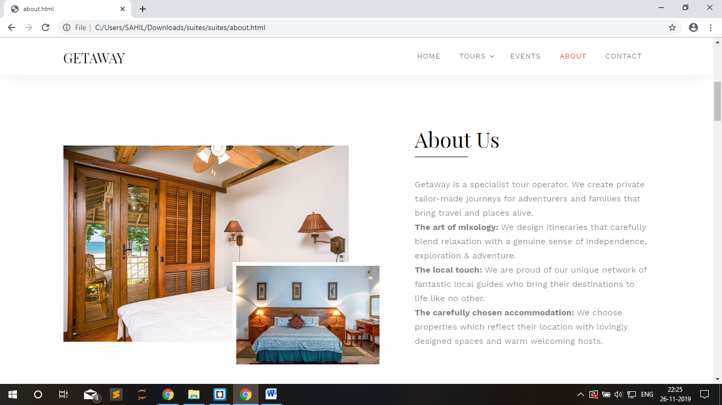

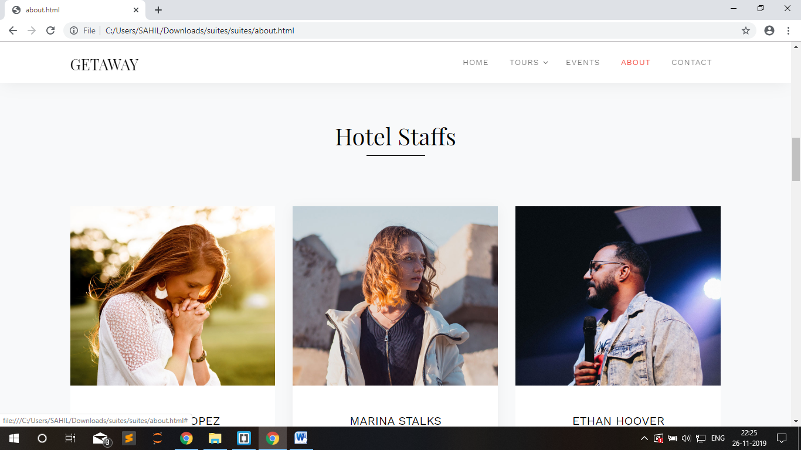

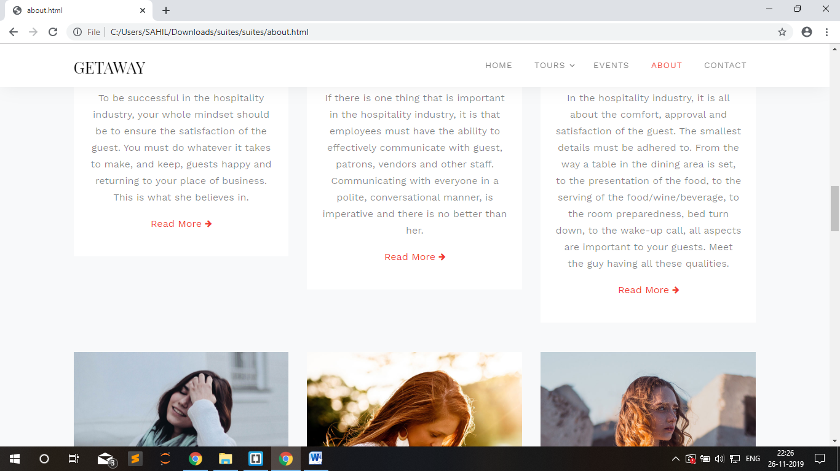

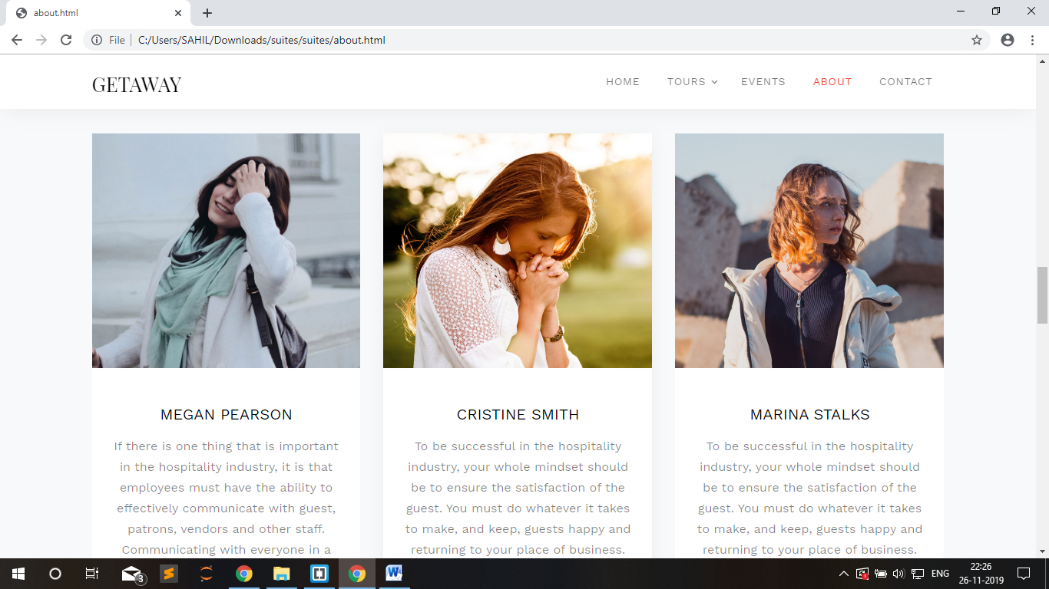

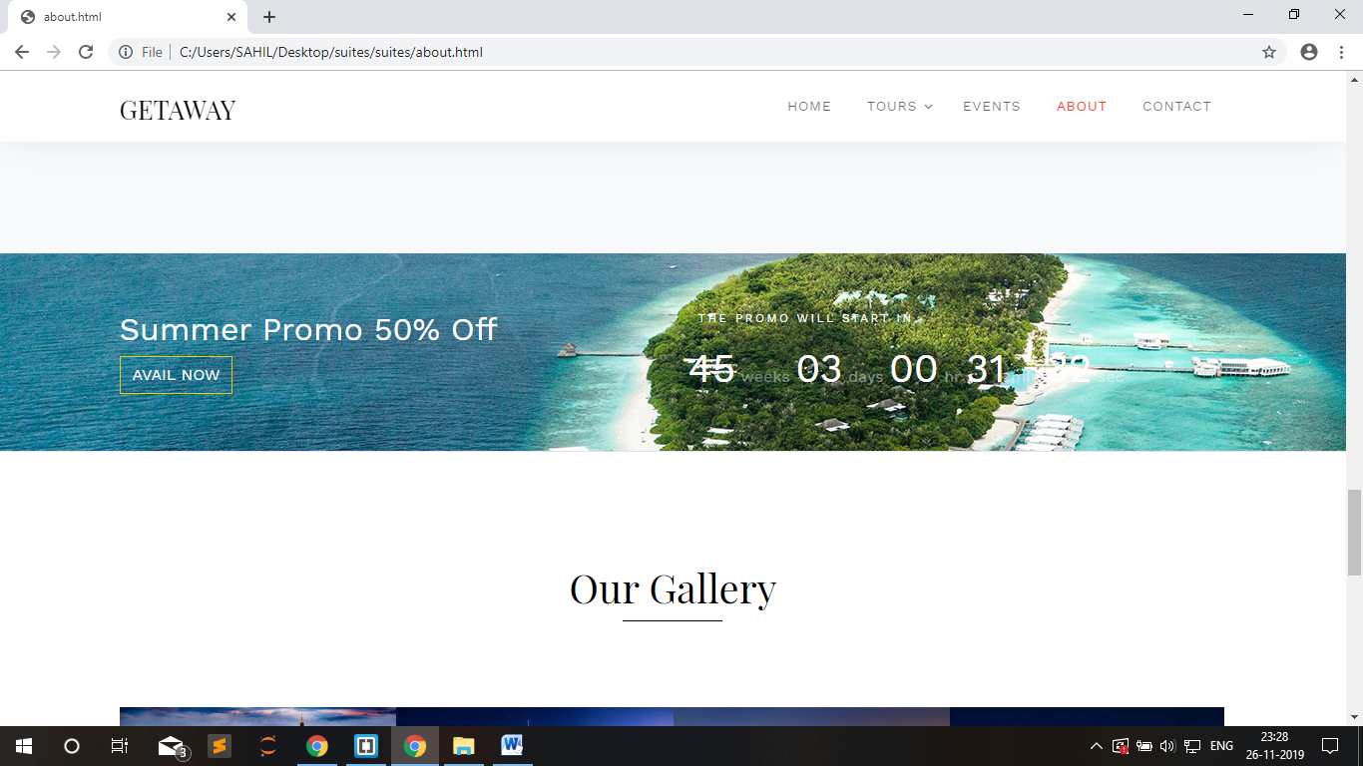

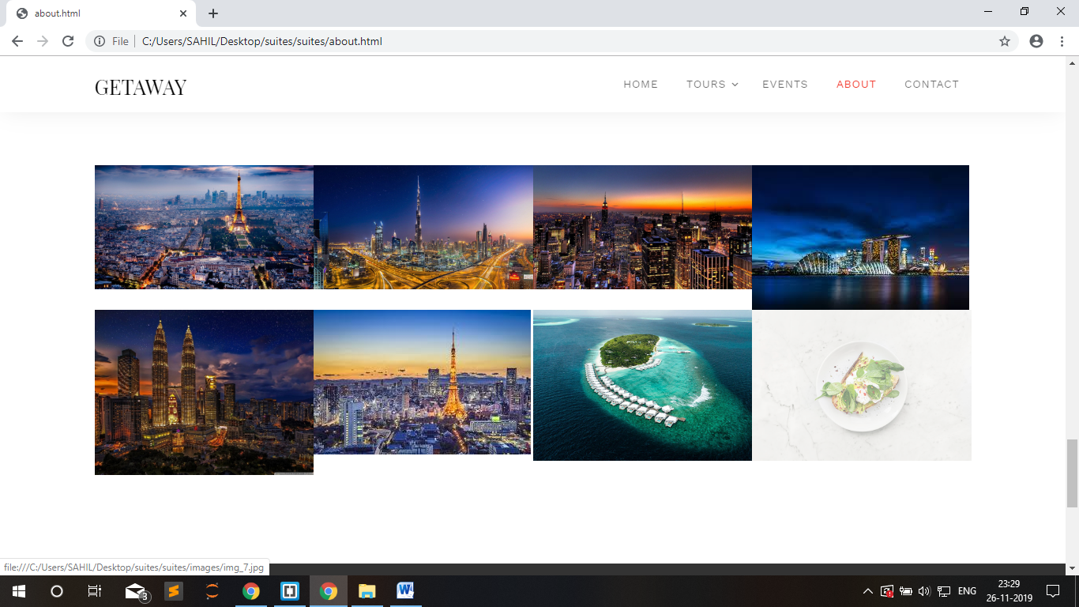

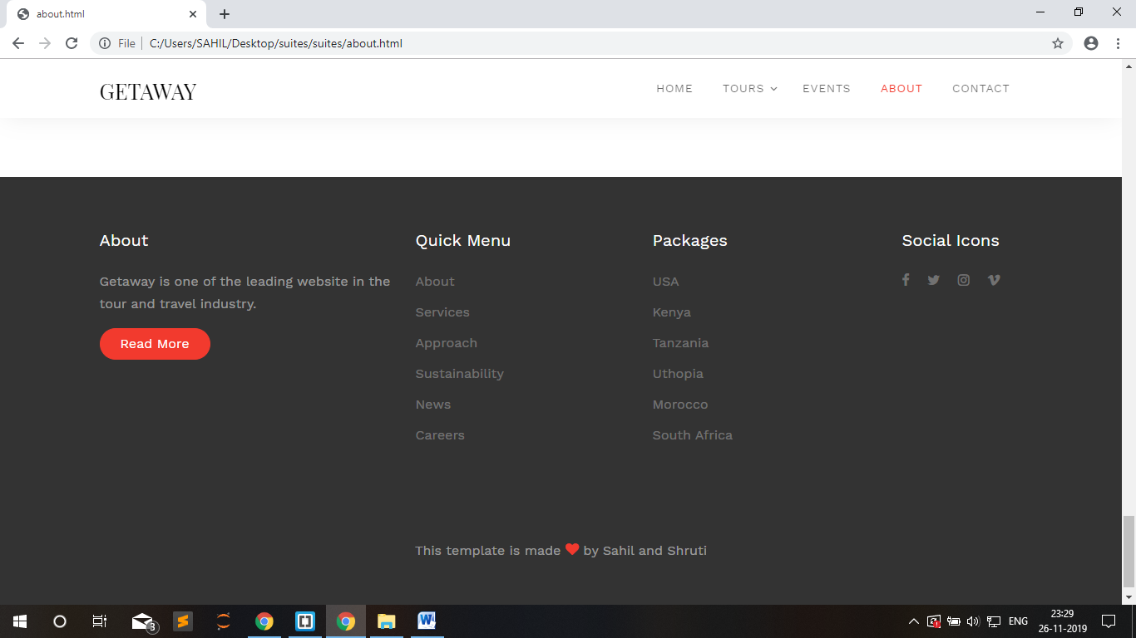

* 1. **CONTACT PAGE**

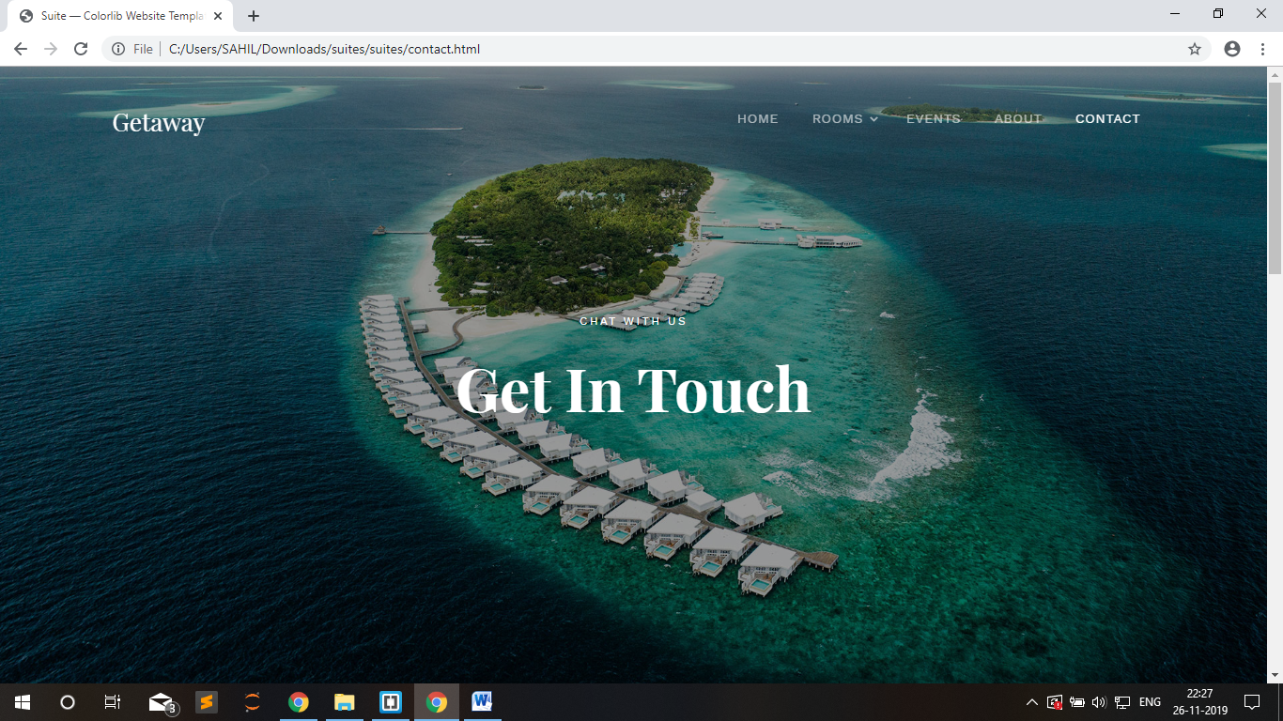

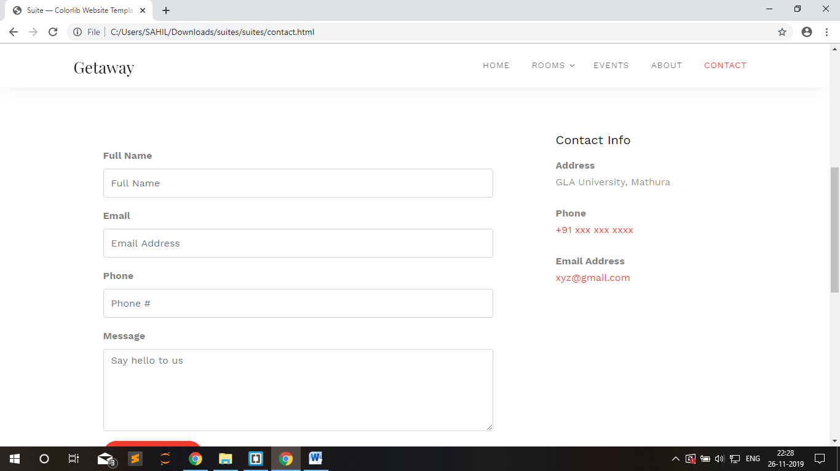

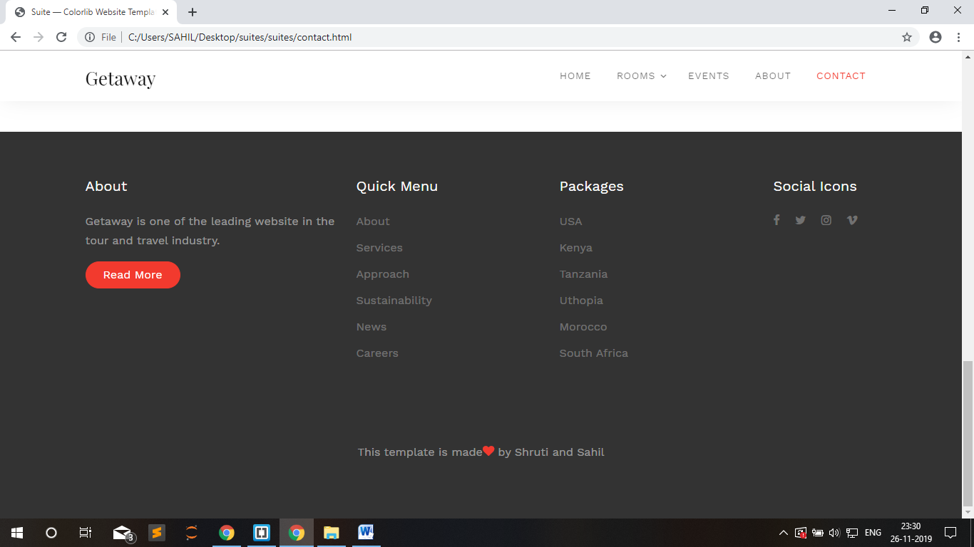

* 1. **EVENTS PAGE**

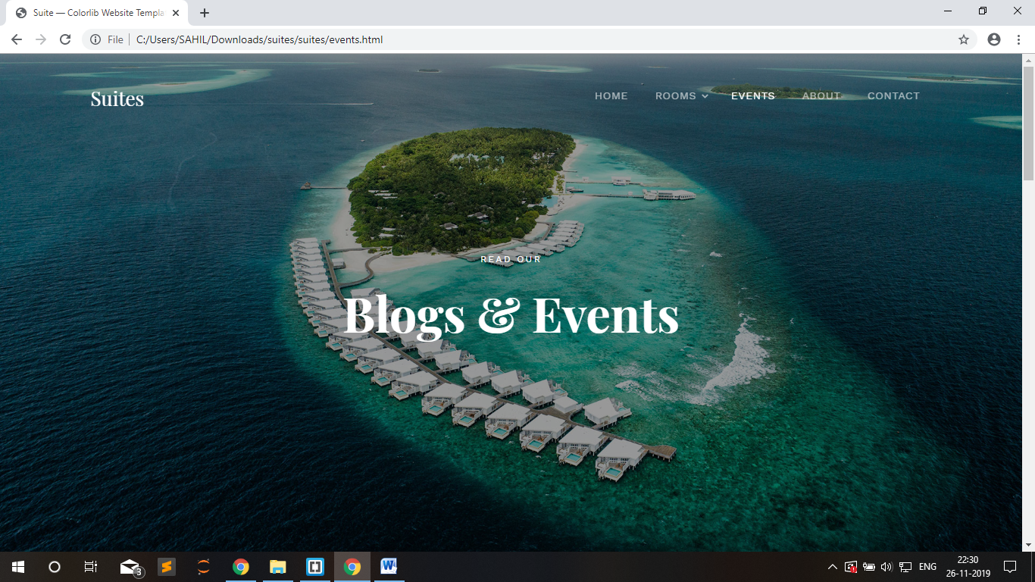

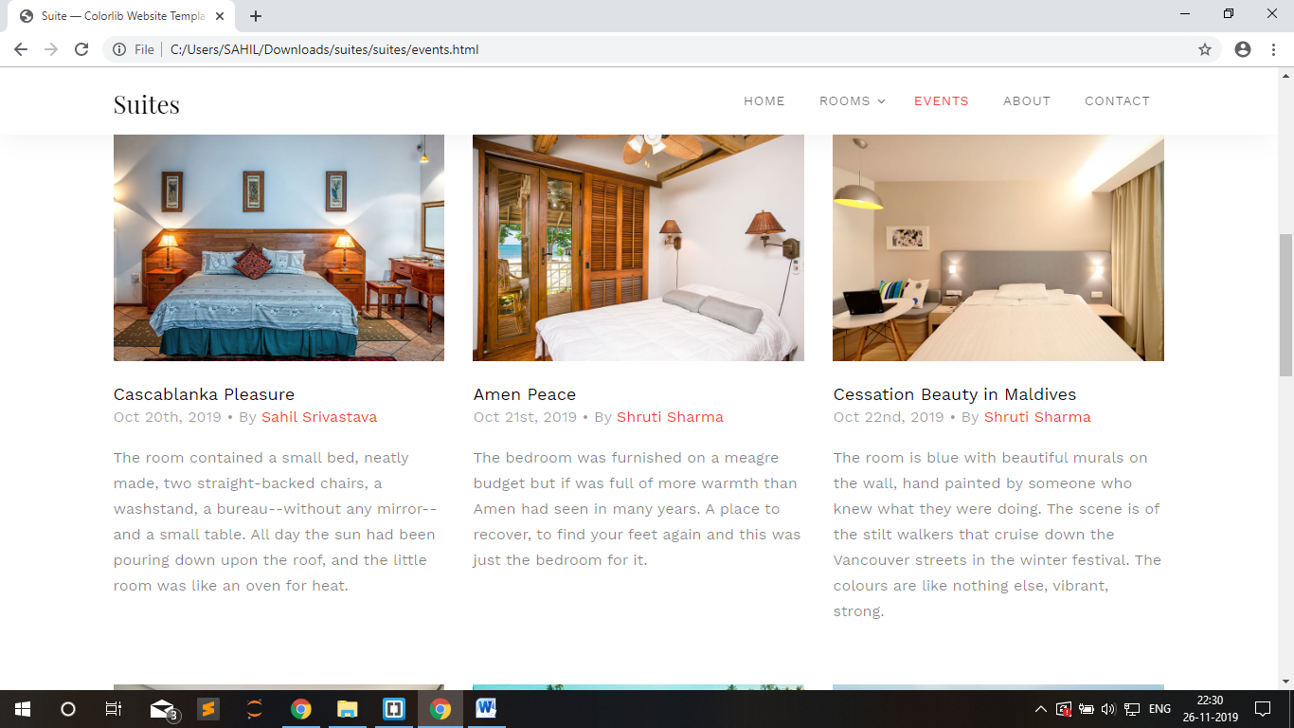

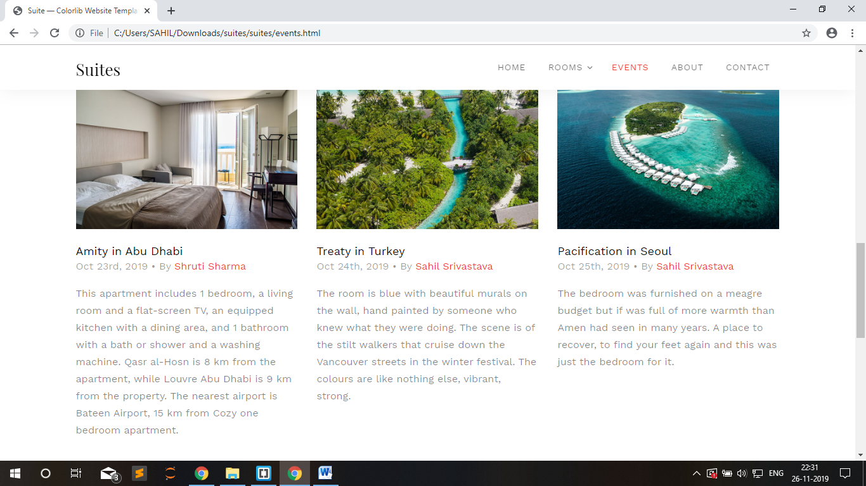

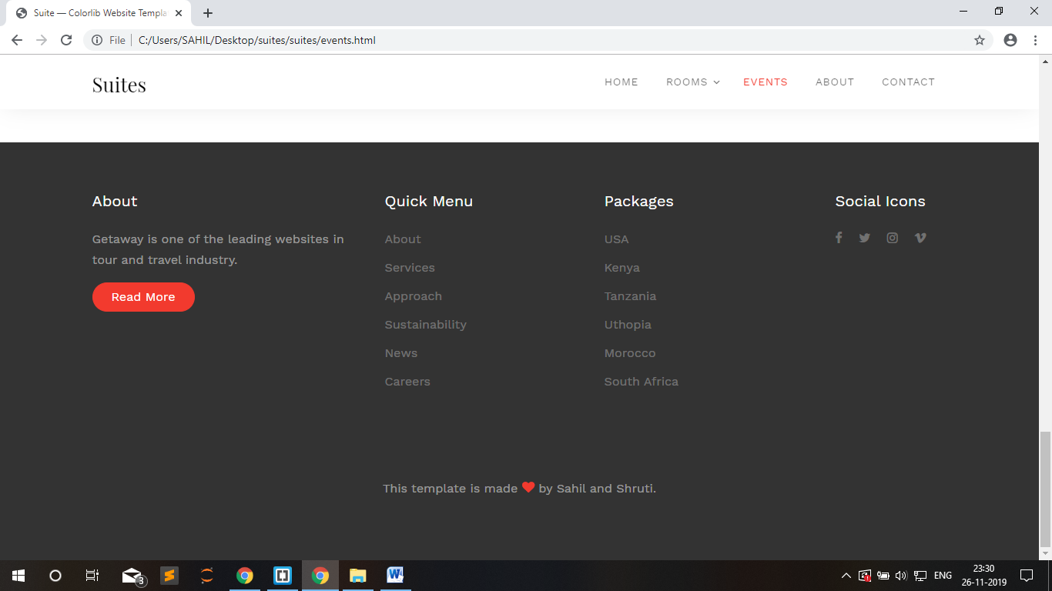

**BIBLIOGRAPHY**

* <https://www.w3schools.com/html/default.asp>
* <https://www.w3schools.com/css/default.asp>
* <https://www.w3schools.com/js/default.asp>